**Lesson 06 Demo 7**

**Create an S3 Bucket Using Terraform**



**Steps to be performed**

1. Set up Terraform components
2. Create Terraform execution plan

**Step 1: Set up Terraform components**

1.1 Run the below commands in the given sequence to set up the Terraform component:

***pip install awscli***

***sudo apt-get update***

1.2 Create a new file to execute this project.

***mkdir s3back***

***cd s3back***

**Step 2: Create a Terraform execution plan**

2.1 Create **creds.tf** under **s3back** and add the code given below:

***nano creds.tf***

2.2 Paste the below code:

***provider "aws" {***

***access_key = ""***

***secret_key = ""***

***token = ""***

***region = "us-east-1"***

**}**



**Note**: Use the AWS access credentials provided in the AWS API Access tab in your LMS in your PRACTICE LAB tab as shown in the screenshot below:

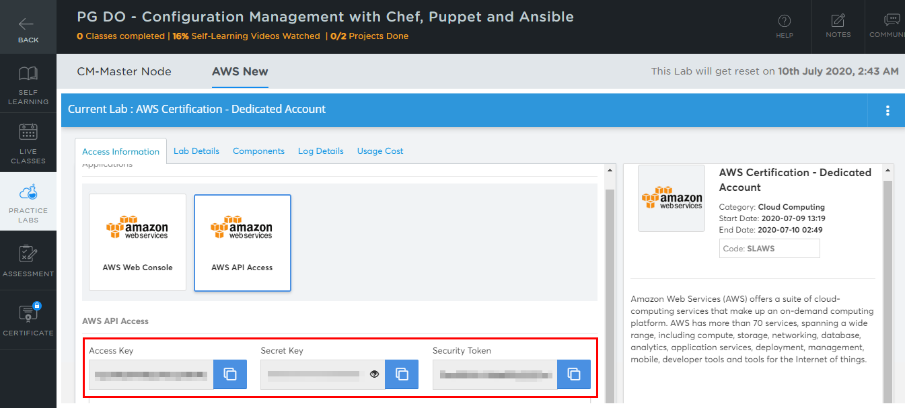

AWS access credentials will change when the AWS Lab session expires, every four hours.

2.3 Create **main.tf** under **s3back** and run the code given below:

***nano main.tf***

2.4 Paste the below code:

***resource "aws_s3_bucket" "b" {***

***bucket = "my-tf-test-bucket"***

***acl = "private"***

***tags = {***

***Name = "My bucket"***

***Environment = "Dev"***

***}***

***}***

**Note:** Bucket name (here my-tf-test-bucket) entered here should be unique globally otherwise it may throw an error while executing the script.

2.3 Run the below commands in the given sequence to add the AWS providers:

***terraform init***

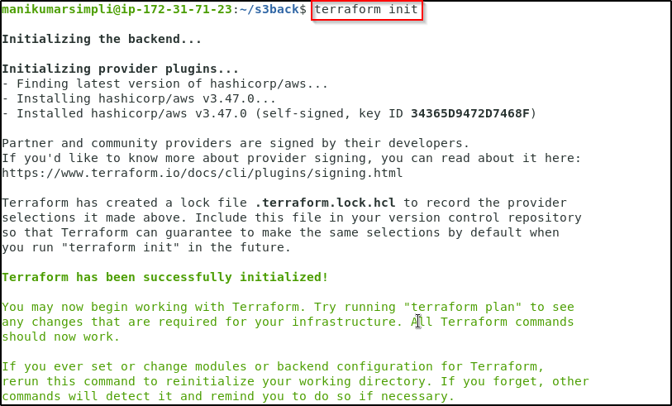

2.4 Run the command given below to commit TF state:

***terraform plan***

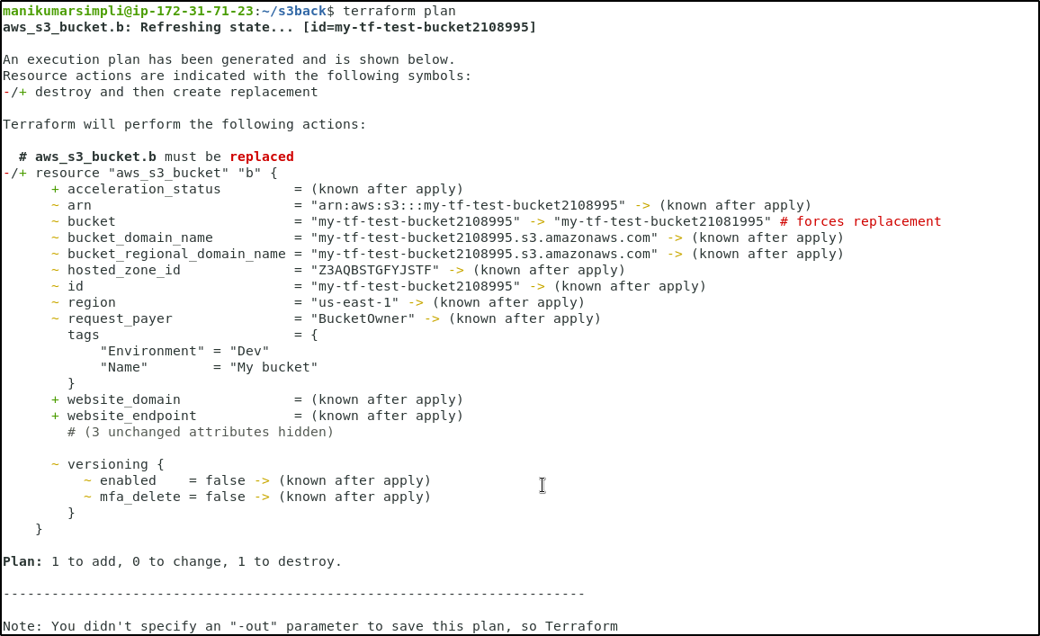

***terraform apply***

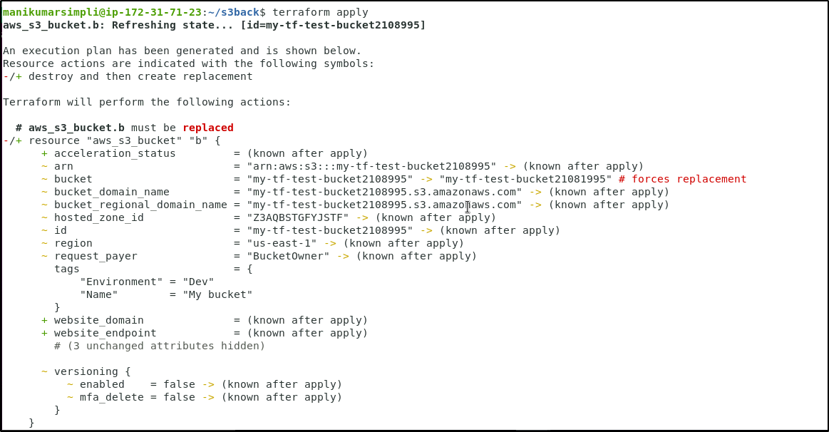

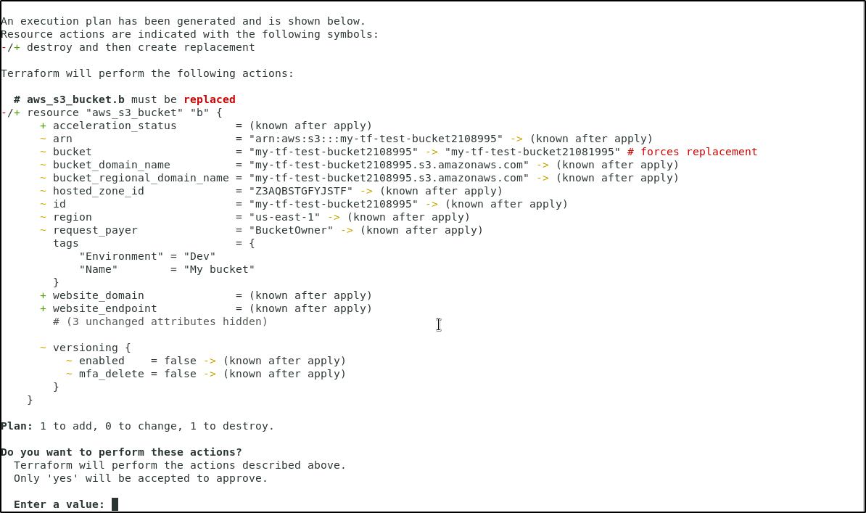

**Enter a value**: Yes

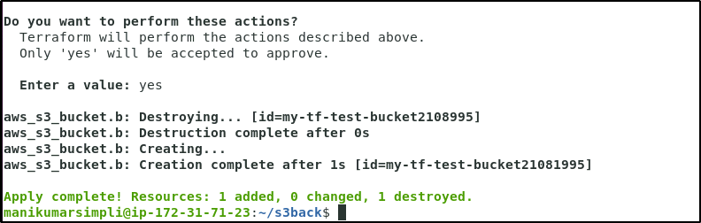

2.5 Verify the creation of S3 bucket in the AWS Management console

